|  |
| --- |
|  |
| **DRAFT**  **Approach for MidCorp MIS**  **Based on GIRDA Foundation paper**  **(Status as at August 14, 2020)** |

|  |
| --- |
|  |

**Document Information**

|  |  |
| --- | --- |
| **Document** | MidCorp MIS |
| **Version** | Version 0.1 – May 2020 |
| **Date created** | 27.05.2020 |
| **Sources** | MIS Foundations / ASPIRE Didactics / CSD as source documents/ GIRDA Foundation paper |
| **Author(s) & Contacts** | Stefan Habereder - Co-project lead MC MIS- AZ Re, Business requirements workstream lead  Myriam Boudet (AZ Re Data Office) – Design Solution workstream lead  Draft v0.1 reviewed by:  Svea Rahne (CDO - AZ Re Data Office)  Rohan Thakur (AZ Re Data Office)  Raed Naser (AZ Re Data Office) |
| **Department** | AZ Re Data Office |
| **Contact person** | Myriam Boudet |
| **File Name** | MidCorp MIS Solution Design Paper |

**Document changes**

|  |  |  |
| --- | --- | --- |
| **Version** | **Date** | **Review** |
| V | DD.MM.201X |  |
|  |  |  |

**Document authorization**

The content of this document have been reviewed and approved as follows

|  |  |  |  |
| --- | --- | --- | --- |
| **Version** | **Date of authorization** | **Valid from** | **Authorized by** |
| final | DD.MM.201X |  | Sign off by MidCorp business lead & MidCorp MIS SteerCo members |

**Table of contents**

1 Introduction 5

1.1 Background 5

1.2 Document purpose 5

2 GIRDA’s strategic ambition 6

2.1 Current situation 6

2.2 Shortcomings of current situation 6

2.3 GIRDA response 7

2.3.1 GIRDA mission 7

2.3.2 Approach to data collection 7

2.3.3 Value potential 8

2.4 GIRDA Path 8

2.5 GIRDA for MidCorp toward MC MIS 8

2.5.1 Context 8

2.5.2 Transition phase 9

3 MC MIS 10

3.1 Key principles and required business functionalities 11

3.1.1 Original OE data is imported ‘as raw’ as possible and stored 11

3.1.2 Implementation of additional data elements in ‘DWH Layer’ 11

3.1.3 Full load of data delivery and storage 12

3.1.4 Reporting Frequency 12

3.1.5 Reference tables and master data management 13

3.1.6 Currencies & fx requirements 13

3.1.7 Data set import validation rules 14

3.1.8 User roles 15

3.1.9 Access right management process 16

3.1.10 Integration of gobal tools into GDP 16

3.1.11 Integration of financial information into GDP 16

3.2 Reporting Layer 17

3.3 On-boarding & delivering entities 17

3.3.1 OE Onboarding 17

3.3.2 OEs in scope 18

3.4 Development of data scope overtime 19

3.5 Update of Data Standards 20

ANNEX - Definition

**List of abbreviations**

|  |  |
| --- | --- |
| ALAE | Allocated Loss Adjustment Expenses |
| ASPIRE | Allianz Standard for Portfolio Information Reporting |
| BI | Business Intelligence |
| CSD | Corporate Statistical Database |
| DI | Data Integration |
| DWH | Data Ware House |
| EPI | Estimated Premium Income |
| ETL | Extraction Transforming and Loading routines |
| FX | Foreign Exchange |
| GDW | Global Data Warehouse |
| GIRDA | Group Insurance Risk Data & Analytics |
| IFRS | International Financing Reporting Standards |
| LoB | Line of Business |
| MCP | MidCorp Pricing Tool |
| PC | Property and Casualty |
| SLoB | Sub Line of Business |
| UWer | Underwriter |
| UW | Underwriting |
| UWY | Underwriting Year |

# 

# Introduction

## Background

Allianz wants to **considerably enhance its capabilities** in **Data Management** to maintain a competitive advantage in the future since data leaders will dominate the industry. This is seen as key factor for competitiveness. As one of the leading insurers of the world, Allianz Group has access to an almost unparalleled wealth of data regarding customers and insurance risks.

Insurance is increasingly dependent on scientific thought and data and analytics, a major strategic priority for Allianz to become a data driven insurance company.

AZ Re is well positioned and sees an **opportunity to provide additional services to Group/ OEs** to:

* Understand customers and their risks and to serve them better with Data & Analytics locally and globally
* Improve reporting, portfolio management and simulation capabilities to steer Allianz Group in a profitable way
* Pool key data points and share top of the line analytics tools and expertise to generate significant value-added at Allianz locally and globally
* Lay the foundations for the future with global framework/platform providing integrated processes, standard data language, harmonized data & analytics in the context of increasingly more shared platforms and tools
* Enable global sharing of structured core insurance risk data (in line with H4 data strategy)
* Combine data aspects and requirements of 3 already initiated strategic programs (MidCorp, CTA, AOMRI)

This requires a **holistic & structured view** on the group’s central key data. As Allianz Re represents a unique data hub in the Allianz group, Allianz Re sees itself in a position to service **Allianz Group but also OEs with more structured and centrally accessible data and become the Group Portfolio Manager.**

To achieve this, AZ Re launched the Group Insurance Risk Data & Analytics (GIRDA) Project to consolidate all cat and non cat risk exposure and claims into a central data base based on Group data Platform. The idea is to simplify and structure AZ Re’s current own data collection processes to a more **unique point of entry and enable data accessibility to OEs/Group.**

## Document purpose

Purpose of this document is to:

1. Create a common understanding of the overall strategy of GIRDA (short to long term targets), by defining:

* The strategic building blocks which will shape the different project phases of GIRDA
* The key guiding principles of data collection and reporting & analytics for project phase 1 (GIRDA for MidCorp)
* The GIRDA for MidCorp transition to MC MIS

1. Outline business requirements for the MC MIS .
2. Sketch roles and responsabilities in GIRDA run phase (to be updated in a later stage)

# GIRDA’s strategic ambition

## Current situation

The current data landscape is characterized by:

* **For OEs**
* Historically grown landscape of individual data warehouse solutions
* Local individual ‘data language’
* Numerous data requests of Group functions, and Az RE often have to be put together manually despite apparent similarity of data requested (e.g. loss information, accounting information, portfolio data…)
* **For AZRE**
* Already acting as a hub for group data to fulfil its business obligations
  + providing reinsurance coverage
  + CAT Portfolio modelling
  + monitors claims for reinsurance and retrocession
  + Pricing model calibration for MidCorp
* Various upload interfaces or and individual data collection have been established
* Allianz Re is consolidating its existing global data standard for cat risk exposure (ASPIRE) into a central GloBI Instance
* The MidCorp tools suite have a different maturity level with a complex integration strategy:
  + Tools are currently being developed on a stand alone basis; GIRDA would need to collect similar data from various sources (e.g. MidCorp tactical pricing solution) ensuring a consolidation based on a unique identifier
  + An integrated solution (Underwriting Workbench) will be developed and provide a harmonised data structure but timing is not yet confirmed.
* **For Group**
* AZ Re’s initiatives and role around data (projects CAT Risk DWH and evolvement into GIRDA) is fully supported and seen as a very good strategic fit from H4 perspective
* The current technical approach for these initiatives is also in line with currently available global infrastructure and AZ Tech offerings (GLoBI, GDW, GDP and MSTR) and therefore is also supported by H4
* Mid to long term technicalities are changing e.g. to virtual access of data instead of physical transfer and/or shift into accessing data directly and near real time from the (local) operational systems vs from in between (local) Data Warehouses
* Lack of common data language and definitions, but the GIRDA semantic harmonization driven via the Data Program of H4 (e.g. Business Glossary) and all connected service offerings remain valid and will represent a corner stone also for the long term future

## Shortcomings of current situation

* **For OEs**
* High, often manual efforts to provide data
* Perception of duplicated efforts due to similarity of requests from different functions at Group level
* Difficult to compare with peers due to different data language & request scope
* **For AZRE**
* Data scope overlapping, but difficult to combine
  + Consistency of data across submissions, e.g. segment definition
  + Aggregated vs. per policy/ insured object
  + Periods vs. points in time
  + Update frequency
* Tool strategy going forward not fully aligned and requiring a complex integration strategy
  + MidCorp tools are currently being developed on a stand alone basis
  + Extension of ASPIRE to include cat claims would need matching based on local policy ID
* **For Group**
* Lacking rationale to centrally collect OEs’ data
* Insights provided through different Group functions hard to reconcile, due to different data definitions, transformation etc.
* Significant time delay of insights due to long data collection and preparation time frame
* Static data lacking options to drill down to better understand

## GIRDA response

### GIRDA mission

GIRDA is about holistic and proprietary risk insurance data to create value at OE and Group level

* Improved retrocession and risk capital allocation at Group level
  + Group portfolio steering
  + Internal reinsurance to benefit from diversification and different jurisdictions
  + External cessions of peak risks to cheaper capital providers
* More refined UW and technical pricing at OE level
  + View of MidCorp across the Group e.g. MidCorp risk by global occupancies
  + Consistent and global view on Cat risk through proprietary loss data
  + Delivered as services and tools (cat model, MCP tool, UW work bench, cat risk management dashboards)

Overall target of GIRDA is to provide a central repository for harmonized insurance risk data across all OE on the level of individual insured objects, policies and claims respectively:

1. **Holistic data horizon of insurance risk data**: harmonized data definition
2. **Institutionalized data delivery:** (at least) monthly delivery of a standardized set of structured data from Allianz group entities and consolidate them into a single repository
3. **Data accessibility**: Providing customers (OEs/Group) an environment that fosters collaboration due to easy access to Global data, pre-configured dynamic reports / dashboards and analytics tools to generate insights
4. **Data enabled services**: Providing on-demand support for customers’ core processes with predictive models

*Benefits*

1. **Avoid efforts of multiple data collections for similar data**
2. **Single point of truth** for all insurance risk related data requirements within AZ Group.
3. Increased **focus on Data Analysis (**predictive modeling, trend analysis, …)
4. **Leverage group know-how**: Enable OE to OE collaboration based on harmonized data definition and access to one source of data for reporting / analytics / BI for business applications world-wide

### Approach to data collection

While having the target picture in mind, the build up of the data asset is oriented at intended business use cases to prioritise data collection requirements.

* Consistent sets of Insured Objects, Policies, and Claims on highest granularity
* Periods of time (rather than points in time)
* OEs remain responsible for correctness and completeness of the data delivered to GIRDA
* GIRDA team and OE collaborate to map data consistently with Group definitions
* Over time data delivery is to be automated as much as possible

### Value potential

Considering the potential value creation, GIRDA is building a significant data asset for Az Group, that is worth investing in

1. **Additional profits** - systematically skimming favorable risks through a targeted go-to-market approach
2. **Lower Re-Insurance pay-out** - AZ OE re-insurance and AZ Re retrocessions premiums saved due to better understanding of own risk
3. **Premium Growth** - Additional capacity through better risk capital allocation

## GIRDA Path

**Path to GIRDA**



1. ASPIRE Cat risk exposure data (2017-2018) in CRDWH
2. GIRDA for MidCorp (2019 - 2020)
3. Potential extended data scope in GDP (2021 onwards)

4 – 5) tbd

First phase is driven by the MidCorp initiative

## GIRDA for MidCorp toward MC MIS

### Context

Late 2019 a MVP was developed by AZ Re Data Office for an immediate specific business purpose. To this day, it serves as the data hub for deep dive work, for OE specific property data which are manually uploaded. A set of dashboards was developed to display business performance in various ways.

Based on a vision of extended use, the MC MIS project was established in April 2020 with the understanding to collect all relevant data on the GDP and to build on existing MicroStrategy dashboards by redirecting their link from the local AZRe Oracle db to the GDP.

The MVP data submission structure serves as the starting point for GDP related development (by H4) under the MC MIS project.

The starting point for MicroStrategy dashboard development under the MC MIS project will be the existing MVP dashboards, redirected from Oracle to the GDP. The GIRDA for MC dashboards will still be maintained and developed by H9, but link directly into the GDP.

There are two separate, but somewhat linked topics which need to be addressed:

* 1. Deep Dives carried out by the MC team of AZ Re for immediate business needs based on the MVP.
  2. Longer term deliveries under the MC MIS project based on the GDP, led by AZ Re and H4.

Ultimately, the deep dives will be carried out under the MC MIS project deliverables and the MVP solution will be retired.

### Transition phase

In order to transition in the most efficient and reliable manner from one platform to the other while minimizing the transfer and execution risk by integrating i) into ii), there is a need to define and specify initial enhancements to functionality and features (in relation to the operational data) to bring the GDP solution from the agreed starting point.

Target should be as follow:

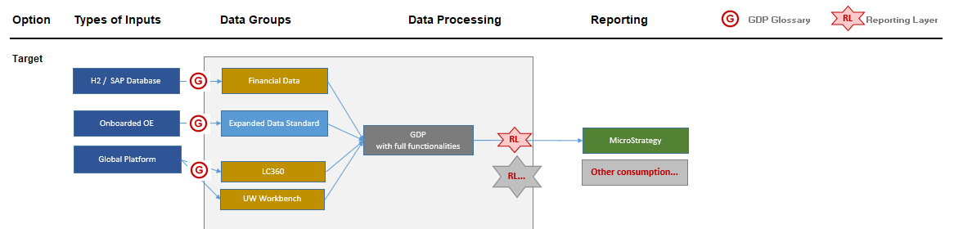

Based on discussion, the following approach was chosen between AZ RE and H4

To include the selected alternative

To add roles & responsabilities

# MC MIS

This chapter aims to describe agreed fundamentals which will shape the scope of GIRDA for MidCorp or MC MIS

In order to set the general frame, some guiding principles will be helpful and should be adhered to whenever possible during the course of the technical implementation – please see below the scope of it.

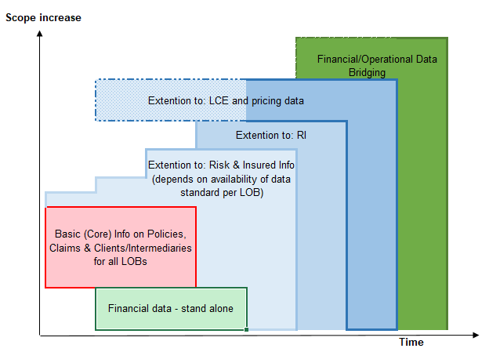

The data scope referred to is:

- **on the operational data from legacy OE system**

**- on operational data from Global tools (e.g LC360 & UWB)**

**- on tactical tools (e.g. MCP)**

**- on the financial data**

**Operational data scope will start with Property, and eventually extend to all MidCorp Lobs**

See dedicated 3.5 on development of data scope

**Implementation will be done in different phases:**

1. For the **legacy OE operational data** the different phases are likely be implemented over time (see chapter on OE-on boarding) .
2. **On operational data from Global tools (e.g LC360 & UWB)**

Plug in to GDP should be forseen in the built phase, including registration of all attributes, reference tables, Data Quality rules.

1. **On tactical tools (e.g. MCP)**

Key question is how much effort needs to be invested in the MCP.

A migration of the operational data to GDP will then be forseen.

1. **On financial data**

A full set of the available financials will be loaded into GDP directy from SAP ECCS or via an Excel file upload

In case adherence of such principles would over proportionally increase complexity or costs, H4 will discuss with H9 before any implementation efforts, how to best proceed on the issue. In the functionality section individual topics will be raised and explained. This is about functionality which is aimed for inclusion in the first MIS version due for delivery end of 2020.

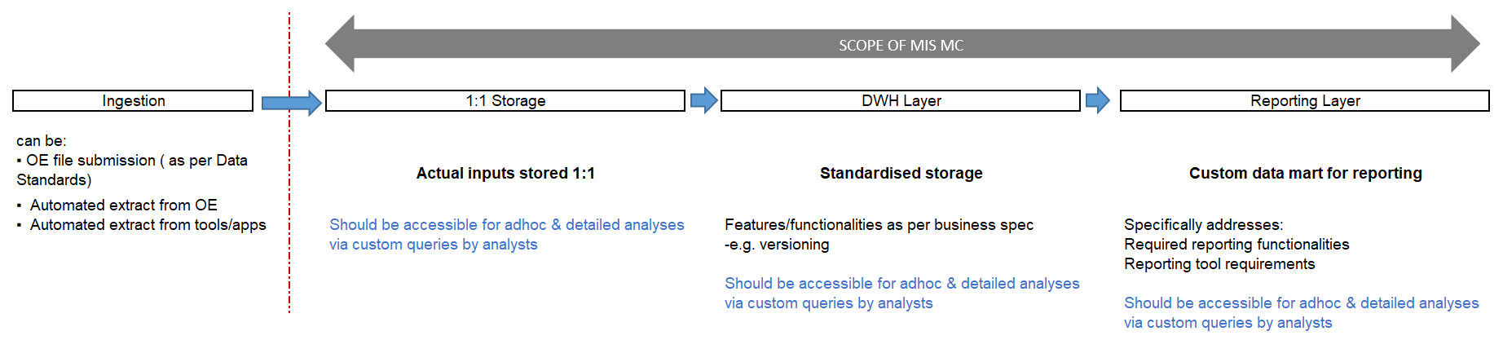

## Key principles and required business functionalities

### Original OE data is imported ‘as raw’ as possible and stored



The GDP should host and maintain a version of the original submission or extract as relevant; i.e. without any or little prior adjustments, conversions or aggregations

### Implementation of additional data elements in ‘DWH Layer’



The current data submission structure is based on the Property Data Standard v1.0. Any additional standards will be seamlessly integrated into the GDP DWH Layer, i.e. it should be expandable / scalable as much as possible rather than sitting alongside.

See dedicated chapter on Data Standards with regards to the **Development of data scope over time**

### Full load of data delivery and storage

**BUSINESS REQUIREMENTS:**

As long as there is a manual data delivery, OE will deliver the full data load for a requested **As At Date**. This means a complete cumulative snapshot for values all latest information fo all attributes and not in an incremental manner.

Any past delivery already used for any reporting needs to be fully re-creatable for data governance and audit trail. A transparent mechanism should be implemented to reproduce any corrections to historical data.

This means that historical reports can always be regenerated (no update of existing data).

**TECHNICAL EXPECTATIONS:**

Storage should be considering the following business requirements:

* Historization: A complete cumulative snapshot for all future data delivery channels as of a **Reporting Date** should be re-creatabled with meta data as of that respective reporting date (to track business decision based on that respective submission)
* Ideally, if there are several deliveries for the same **As At Date** , any 2 submissions should be automatically comparable across all attributes (*see chapter in DQ*) – to be discussed with H4
* For manual delivery, one submission needs to get a final sign off by business in Microtrategy. Any subsequent submission after that signed-off submission is automatically rejected (no upload submission is possible)
* Any other versions for the same **As At Date** once a sign off is done can be deleted
* A Revoke sign-off is not possible and would trigger manual action

Any update on historical data should only be possible via a ‘correction layer’ so that actual values and corrected values can be determined for any reported value(s).

For a streaming from a global platform, this woud also holds true.

For financial data -> tbc

### Reporting Frequency

**BUSINESS REQUIREMENTS:**

Data should be available via the reporting (consumption) layer for various use cases.

**TECHNICAL EXPECTATIONS:**

For reporting layer, we will need all data ‘materialised’ as per Reporting frequency required i.e. if portfolio data has to be available at a quarterly frequency, then the reporting layer should contain all facts materalised per quarter (so that **Reporting Date** can be offered as a selector / filter etc).

This should also facilitate requirements under 2.5 in terms of how much history is made available in a materialized manner.

Example of **reporting frequency** based on:

|  |  |  |  |
| --- | --- | --- | --- |
| Source / data type | Update Frequency on GDP | Update Frequency on Reporting Layer | Comments |
| Operational data | From currently bi-annually to monthly and utlimely daily or nearly real time | As low as possible depending on input data frequency  First step: quarterly | Depends on Process and business use cases |
| Financial data | Quarterly | Quarterly |  |
| MCP (transactional information/ deals information) | Daily or nearly real time |  | Will be decommissioned once UWB deployed to all MidCorp OEs |
| UWB | Daily or nearly real time |  |  |
| LCE | Daily or nearly real time |  |  |

Important note:

Synchronisation of all different frequencies for **combined views** between operational data and global tools; there is a need for a snapshot date (link to the Reporting Frequency for the requested business views)

### Reference tables and master data management

**BUSINES REQUIREMENTS**

Any referencing system, be it AZ ISIC+, fx rates, risk or hazard codes etc.. needs to be dynamically administered, i.e. versioned. When data comes in, valid referencing systems have to exist for all relevant data fields. Likewise, relevant data has to carry a respective version number. We may decide to create additional versions of referencing systems to link old and new reference systems. Examples:

|  |  |
| --- | --- |
| V1 | V2 |
| HazardCode | HazardCode |
| Low | SuperLow |
| Medium | ExtraLow |
| High | Medium |
|  | HighMedium |
|  | High |
|  | Higher |

**TECHNICAL EXPECTATIONS**

All reference data management functionalities are taken care by the GDP tool stack.

See attached our GDM business spec.



### Currencies & fx requirements

**BUSINESS REQUIREMENTS:**

* Historical Figures as at a fixed rate to eliminate fx rate change
* Look at all the figures at a fx plan rate basis (1 rate / year)
* Be able to bridge to financial views ultimately

**TECHNICAL REQUIREMENTS:**

GDP need to interface to these fx Rates, as needed for all Reportings:

* Plan Rates to Eur ( to check with Group if this is the same to all OEs)
* Quarter- end As At Rates (each original currencies to OE reporting currrency)
* Year end Rates

Data Standards Principal:

* For each claim, only one single currency
* Fr each policy, only one single currency

Each OE should ideally have a reporting currency so that aggregated OE views are consistent.

For bridging to financials; additional fields to be included into the Data Standards (next version)

* For financial view, data model should have the ‘transactional EUR’ and transactional OE Reporting currency view included and this should be delivered by the OE and stored
* Any local financial reporting in non-EUR currency would also need to be in the original data submitted, just like the ‘transactional EUR’ amounts

### Data set import validation rules

**BUSINESS REQUIREMENTS:**

**Type of validation rules:**

Before any portfolio set can be uploaded it needs to undergo various validity checks. In particular, if we want to create a proper historization, checks need to be carried out in two dimensions: H and V.

**V:** Within the portfolio set

**H:** Across sets of portfolio at individual policy/claims level which represent the same underlying business over time

*For instance, for each policy in the new submission, automatically check if renewed policy has a corresponding policy entry in the latest previous data submission (with the most recent AsAt date).*

*For each renewed policy in the new submission, check variations of all relevant policy fields between the 2 submissions (e.g variation in amounts of more than x% between Total Sum Insured between 2 submission or if any variation provided in descriptive fields (e.g Policy A for an UWY 2015 in Submission As At Date 31.12.2019 was flagged with an AZ ISIC+ of XXXXXX and that same Policy A in a subsequent Submission As At Date 30.06.2020 was flagged with a different AZ ISIC+ code.*

*Any differences should be produced in a Exception Reports for discussion with the OE*

*For each claim with reported Effective Loss Date falling into the lastest previous data submission, the same logical checks explained above apply*

**Vbis**: In the up-running to the ultimate ‘automized’ on-boarding process, an additional set of checks between 2 versions of the same data set is needed (to be disussed with H4)

**Display of checks:**

Those validations need to be run for any portfolio set and exception reports generated and such exceptions need to be resolved (some may be resolved automatically according to pre-set rules, others may need manual intervention -> ‘Clearing house’ concept with proper activities / change tracking).

Therefore, it is not only a question of data base functionality which is needed, but also a process topic, i.e. clearing positon and clear surrounding processes (signoff, referral, clearance of data, dynamic mapping systems [changing reference systems]) will be need to be sorted in order to collected and maintain collection of good quality data.

The exception system needs to provide a clear log of activities.

From a process point of view, before a specific portfolio set is uploaded for the first time V has to be executed successfully and any exceptions be resolved sign off process to be also implemented.

Once the next updated portfolio set (portfolio set for the same underlying business, just with a different AsAt date) comes in, V and H need to be run, but obviously V again needs to be successfully resolved before H is executed.

.

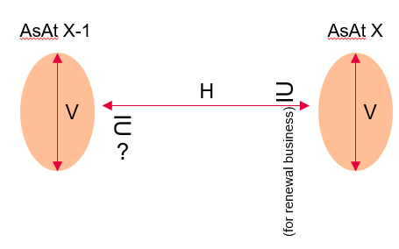

**TECHNICAL IMPLEMENTATION:**

The various validation rules should be implemented in GDP. Results & exception Reports should be shown in Microstrategy:

* DQ for each OE data submission -> see attached current version 
* DQ checks between different versions of a same submission -> to be discussed with H4 (need to highlight differences between 2 versions)
* DQ checks between 2 OE data submissions as at a different Reporting Date -> WiP - as per business requirements

### User roles

**BUSINESS REQUIREMENTS:**

As we are onboarding more users and more data, we need to have a proper access rights management and user roles in place. User roles need to be defined for both, database and MicroStrategy.

Leaving technical details aside, business needs access rights (in the MSTR environment; whatever is done on the db should not be restrictive to the dashboard rights) to be split per OE, OE regional split, group of OEs, All OEs,…) and data sources/Lobs (Property, Liability, Engineering, etc., financial data, LCE,…).

Possible Dimensions:

* Person / function / roles
* Operational Entities / Hubs / Group
* Lob
* Data source (operational, financial, LC360…)
* MSTR roles

|  |  |  |  |  |  |
| --- | --- | --- | --- | --- | --- |
| **PERSON1** | Policy data | Claims data | Fin data | LCE data | … |
| OE1-MAIN |  |  | X |  |  |
| OE1-BRANCH1 | X |  | X |  |  |
| .. |  | X |  |  |  |
| OEn |  |  |  |  |  |
| Hub |  |  |  |  |  |
| Group |  |  |  |  |  |
|  |  |  |  |  |  |

To be taken into account: the minimum legal requirements for data security at Group level and OE level & the automized process to grant & administer a variety of above mentioned roles

**TECHNICAL IMPLEMENTATION**

*To be discussed with H4 on an automized approach for the attribute level access taking account existing set –up via GIAM (expansion of no of roles would required extensive manual administration if it is done as currently)*

### Access right management process

**BUSINESS REQUIREMENTS:**

Automated reports and processes for (a) approval (ideally two step – product & line manager) and (b) audit via GIAM or relevant tool.

Tool should provide lists for sign-offs and further governance and maintenance.

**TECHNICAL IMPLEMENTATION**

*To be discussed with H4 on the best approach for the attribute level access taking account existing set -up*

### Integration of gobal tools into GDP

**BUSINESS REQUIREMENTS:**

**LC360**: pre-requisite is that policy id is entered to link to the operational data. However, stand alone dashboard reports would still be of a value to LC Group & local community

**MCP**: source of MidCorp Property & Liability deal information in a stand alone tool, but at the time of pricing, no policy id inserted. Therefore MCP data cannot be linked to operational data.

A stand alone reporting soluton including dashboard for Property & Liabilty, and combined views are available. MCP inclusion to be re-visited

**UWB**: integration to operational data should be possible at a later and should be looked into.

Important Note:

Any new assets integrated into the GDP which are linked in any shape or form to already existing data has to be available for joint reporting. In other words, linked data all sits in one reporting universe.

All such data would need to be prepared in specific reporting tables with clearly defined relationships to existing data, to be effectively included in the reporting solution.

### Integration of financial information into GDP

Ongoing discussions with H2 how best to extract / push data to GDP.

Reporting layer and dashboards are in WiP

**BUSINESS REQUIREMENTS:**

Financial dashboard templates have been identified. Specific features such as drill down, links or currency conversions and other filters etc. need to be integrated.

All dashboards are currently based on available SII LoB reporting database data fields.

For the time being still some manual intervention will be needed to properly identify all MC portfolios. This needs to be specified and detailed out in order to find the best possible implementation approach.

## Reporting Layer



AZ Re Solution Design team to work on the Reporting Layer as it will feed MSTR Layer

Reporting layer will contain cumulative position per As At Date to be able to produce triangles view of relevant KPIs

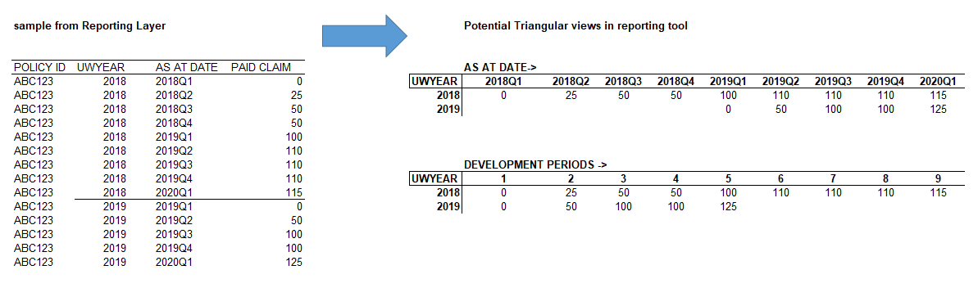

## On-boarding & delivering entities

### OE Onboarding

The OE-On-boarding of operational data is based on their data situation:

* Some OEs will submit their data set ad hoc as the GIRDA for MidCorp Data Submission Structure.
* Some OEs have data mart in place which could be connected directly to the various functionalities of GDP (Business Glossary, Fitness….)
* Some OEs have in place an automised process in place from the local data sources to GDP without any manual process steps

Important is to clearly define what ‘on-boarding’ entails :

**Business requirement on OE on-boarding**

Minimum DQ criteria (no deviation to DS) & frequency is acceptable (tool agnostic)

* Represent business in the OE onboarding task force, i.e. lead efforts to understand their entry and data process from a business point of view.
* Work closely with respective Hub Heads to identify issues and solution from a business point of view

Current Pilots are UK, France and BLX. Priorities may shift as with project requirements and focus

**Technical on-boarding**

The various components of the GDP are used (see below picture).

The OE data (data provisioning coming from raw source tables, data mart, csv, etc) are retrieved & documented in the Data Management tools suit :

* **Business Glossary**: holds all business terms with harmonized definitions, info w.r.t. completeness, quality, accessibility, global reference values etc., with Data Ownership appointed and Governance processes defined.
* **Data Dictionary and Catalogue:** connects Business Terms from the Glossary to Technical Fields and Data Models
  + manages the names, descriptions, structure, characteristics, storage requirements, default values, relationships, uniqueness etc.
  + Contains information about systems, sources, locations, owners in the organization
* **Data Lineage:**  describes the transformations applied to Glossary Terms and corresponding Dictionary Attributes (Extraction & Transformation logic to target schema is automized)

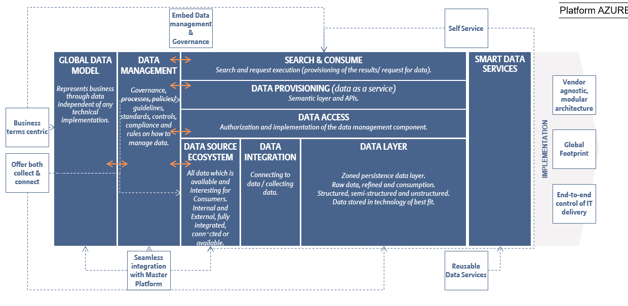

### OEs in scope

All legal entities of Allianz Group (consolidation units) which are in scope of the MidCorp initiative

Short term:

2019 : Started with 5 lead OEs (AZ France, AZ Germany, AZ UK, AZ Autralia, AZ Benelux)

2020: Tier 2 OEs (AZ Spain, AZ Italy, AZ Turkey and AZ Switzerland)

Medium to long term target: Tier 3 OEs…

A realistic staged approach in terms of roll-out is to be decided taking into account the local OE data sources system and interface change (time and cost) for delivering the MidCorp data scope.

**Out of scope**:

Any entities which are not underwriting insurance; e.g., asset management (Group assets collected via IDS)

## Development of data scope overtime



Phase 2

Phase 1

Generally, data will be collected based on availability and importance and phased in over time. We will start with Core information on policies, claims and clients/intermediaries. This is information which is available (in the same format) across all LOBs.

Operational data (collected from each OE individually)

Basic info on policies, claims and clients/intermediaries available for all LOBs. This should be available for all OEs. For detailed info on data fields included refer to the appendix.

This will be supplemented with Risk (e.g. Perils) and Insured Object information (e.g. Locations) over time. This information might differ from LOB to LOB. This may be more or less complex to extract from OEs, depending on their source systems. This means timing may differ across OEs and LOBs.

Reinsurance specific information will be added at some later stage

**The data standards for all LOBs need to be completed. Goal is to have a basic standard available for each LOB:**

* + Property: OK
  + Engineering: Use Property ?
  + Liability: ?
  + Motor fleet: Use Property?
  + Other: ?

Financial data (collected centrally)

* *Phase 1, stand alone:* Financial data is collected via H2 SII database. Financial data will initially be standalone (not linked to Operational data).

Financial data is provided as ‘static’ aggregated data set on financial year basis whereas operational data is provided in non-aggregated form (policy by policy, claim by claim) on underwriting year basis.

* *Phase 2, bridging with operational data:* Two dimensions (aggregated vs. non-aggregated data and underwriting vs financial year information) need to be brought together and bridged

This will be done at a later stage once:

* + data quality is good enough,
  + sufficient granularity on the attributes on the financial data has been introduced, such as: operational data covers all underwriting years contained in the financial years, fx-rates used are transparent and available or claims break out in paid, outstanding and IBNR components are available for the financial data set.

LCE data

* LCE information will be added from the local LCE datasets. It needs to be added in a way that it properly and efficiently links to the insured object and relates to the operational data above.

Pricing data and other assets

* Other information and assets will be identified and added at a later stage.

The speed at which data sets can be extended or additional data sources added depends not only on the OEs source systems complexity but also on the key resources needed to handle each such additional step. This needs to be carefully evaluated to avoid any resource bottlenecks.

**The timelines, dependencies of phasing in the different data sets needs to be established and agreed.**

## Update of Data Standards

Current Version of our GIRDA for MidCorp is Data Standards v1.0 (please see attached)



Based on our development timeline and scope increase, the Data Standards will be updated accordingly.

WiP to adjust to Core information across Lobs & Lobs specifics as well as inclusion of financial data.

Forseen potential update to be documented and validated by GIRDA for MidCorp SteerCo

**Business Requirements:**

1. Split of Policy & Claims between sections

Stefan to validate with Alban (Head of MC Portfolio Analytics – AZ RE) if needed as part of the core information

*In the MVP version exists only one ‘row entry’ per policy. However, a policy could hold multiple separate sections such as PD and BI.*

*Question: If sections are separately provided we should record them in the system?*

*What we have seen so far is that AZ UK provided them separately under a common policy ID (2 separated rows) and AZ Germany has clear separated policy IDs for PD and BI). We need to clarify whether the UK policy sections are sold as ONE policy and whether the Germany PD and BI sections are sold SEPARATELY. If both assumptions are correct, we can record them as is without any amendments required, assuming each sections is complete (stands on its own iro premium, expenses, limits, etc.)*

*We will run into issues if:*

* *The above is not correct for any OE*
* *Sections are split but not complete, i.e. no premium per section but only on total at policy level.*

*In the current structure, a policy sits at the same level as a section, i.e. no distinction is made really.*

*Will we need a hierarchy between policy and section in the structure? We need to understand what OEs are doing in their systems (polices vs. sections, complete vs incomplete, sold as package vs. seperately) Also, a starting point is to understand what we are doing in the UWB?*

*Based on the findings in the above we may decide to introduce an additional hierarchy level.*

Will PD and BI part always be reported as separate claims? Possibly not in case a policy covers PD and BI combined. Again, we need to find this out with the OEs.

*Ideally, overall granularity should be clearly established so that when data is collected and prepared for reporting there is a clear logic how various KPIs provided at different granularities in the data model are put together … and what are the keys to join across tables … especially where they may feed a common formula.*

*Proposal to have a main section per policy where major KPIs are populated, and this drives the standard views. Sub sections should then only provide specific drilldowns as required.*

*All such logic needs to be clearly defined to have a consistent data model and also a proper reporting logic setup.*

*In the ‘as is’ the GIRDA POLICY ID was defined to contain any sub-policy information and function as the key to go across tables.*

1. Additional flag

It is important to understand which fields are inclusive or not of specific information:

For example: Two companies: A reporting at a very granular level while B only at higer level:

A: Claim_P =100; ALAE_P=10; Claim_OS=30; ALAE_OS=5;

B: Claim_P =60; Claim_OS =100

How can we make sure that Company B has included ALAE_P in Claim_P and ALAE_OS in Claim_OS?

* DS2.0

**Annex A - Definition**

**1 – Time Dimension Definition**

Important is to have a common understanding of the various terms referring to a time dimension. All terms to be registered and defined in the Business Glossary.

**As At Date (= lastest date of the Reporting Period)** : it refers to the original sytem cut off date for data extraction; e.g. 31.12.2019 for quarterly reporting

**OE Extract Date**: it refers to the date extract was produced; e.g. 15.01.2020. Often a later OE production Date or Extract Date enables to take into account both late policy processing and allows for notification / claims development for losses close to the As At Date (e.g. 31.12.2019.)

**OE Submission Date or OE Delivery Date**: it refers to the date when the OE send their data extract to Group; e.g. 20.01.2020

**Load or Ingestion Date**:it refers to the date (known as timestamp) the data set is ingesting in the data pipeline; e.g. 22.01.2020

**Reporting Period**: it refers to the date shown in the various dashboards / reporting views; e.g. the reporting period is 31.12.2019